**The Adaptability of students after the transformation to online learning**

Ramez Khdour1 and Raneem Qaddoura1

1 Al Hussein Technical University, Amman 11831, Jordan

21110139@htu.edu.jo, [raneem.qaddoura@htu.edu.jo](mailto:raneem.qaddoura@htu.edu.jo)

**Abstract:**

**Through rigorous analysis, big data technologies reveal complex patterns and relationships among variables such as study time, online connectivity, and availability of self-learning management systems (LMS). Since the covid-19 pandemic hit the world we were forced into online learning, students from all around the world faced some challenges when they got introduced to this new reality, it is crucial for educational institutions to ensure students adapt to online learning. This research explores what affects the adaptability levels of students in online learning based on various factors such as age, gender, education level, internet type, location and the impact of the availability of self-LMS. Moreover, determining what is the most accurate prediction model that could be used. The analysis showed that age and education level increase the adaptability if they are higher, men are more adaptable to online learning, and the availability of a WIFI connection is crucial for their adaptivity. It was found that LMS systems and good network connections are crucial because of their reliability.**

**Keywords:** big data, adaptivity, online learning.

# Introduction

[14] A challenge that rose in different industries as data continuous to grow, data scientists, even though there is a lot of algorithms that could manage data like divide and conquer, iterative data analysis, and mining algorithms but the flexibility and scalability of these algorithms are limited. In this day and age, the count of data has caused an explosion in data across various industries. This data is known as “Big Data”. Big data comes from a wide range of sources like transaction processing systems, customer databases, documents, emails, medical records, internet clickstream logs, mobile apps and social networks. Big data is recognized by its huge volume, velocity, variety, and veracity. To get value from big data it requires to us to use various analytical techniques and technologies capable of processing, managing, and extracting meaningful insights from these massive datasets. Could enhance growth and optimization for healthcare, education, and many more which would become a helping hand for decision-making, prediction, and unlocking new opportunities. Moreover, [14] complexity and connections could be established through big data, therefore we can gain new insights that are only discoverable through advanced analytical methods and techniques. The complexity that it has suggests the need for prediction models like machine learning to uncover hidden patterns, correlations, and causal relationships within the data. By utilizing big data organizations can gain deeper insights into customer behavior, market trends, and operational efficiencies, driving innovation and competitive advantage in a data-driven world.

A dramatic shift to online learning has occurred during the COVID-19 pandemic, big data played a huge role in understanding and enhancing student adaptability within online learning environments. Through this transition, [14] big data has increased the volume, velocity, and variety of data generated by students, educators, and learning platforms alike. Using the obtained dataset which contains Gender, Age, Education Level, Institution Type, IT Student, Location, Load-shedding, Financial Condition, Internet Type, Network Type, Class Duration, Self Lms, Device, and Adaptivity Level. [4] We can gain in-depth insights into the factors influencing student adaptability in the digital realm using advanced data analytics tools, by uncovering hidden patterns between various variables.

Using big data analytics helps us to identify and predict student behaviour, academic challenges, and their needs for a more satisfactory experience. Which will empower educational institutions to track student trends in adaptability, and use of iteration methodology in teaching to optimize learning continuously.

Furthermore, [14] big data serves as a way for evidence-based decision-making in education, By gathering insights from a variety of data sources, including student performance data, demographics, and feedback mechanisms, stakeholders in education can make informed decisions establishing a more flexible and resilient curriculum. Specifically, big data holds tremendous potential to drive innovation, improve student achievement, and foster a culture of transformation and lifelong learning in the digital age.

Study questions:

**The research question of this study is**: What influences the adaptivity of IT students in online learning environments, when considering factors such as demographic characteristics (gender, age, educational level), the availability of learning management systems (LMS), and changes in internet types and network connections. and how effective are predictive models in identifying students’ adaptability following the transition to online learning?

Study objectives:

The study aims to critically examine the determinants of the adaptability of IT students participating in online learning environments. Firstly, the study aims to identify key factors affecting student adaptivity, which include variables such as demographic characteristics, technological infrastructure. Secondly, it seeks to examine the unique effects of individual characteristics such as gender, age, and educational level on student adjustment, clarifying the nuanced patterns and relationships in the data. Furthermore, the study attempts to assess the role of the Learning Management System (LMS) with its benefits and challenges in place in shaping students’ adaptivity levels, and to assess its importance as a facilitator of personalized learning experiences. In addition, the study examines the impact of online and network type on student adjustment, and explores how changes in internet type influence engagement and performance in online learning environments. Through this multi-faceted analysis, the study seeks to contribute valuable insights to online education, informing the design of flexible learning environments and strategies for improving student outcomes in the digital age.

The remaining of this paper is organized as follows; Section 2 presents the related work. Section 3 discusses the data collection and description. Section 4 illustrates the proposed approach. Section 5 presents the experiments and results. Section 6 concludes the work and provides recommendation based on the conclusion. Finally, Section 7 discusses the reflection of the work.

# Related Work

Through rigorous analysis, big data technologies reveal complex patterns and relationships among variables such as study time, online connectivity, and availability of self-learning management systems (LMS) [14]. These insights shed light on the nuanced relationship between technology, socioeconomic factors such as financial status, and the levels of adaptability exhibited by students navigating e-learning environments [14]. Analysis of big data not only enables the identification of barriers to adaptation, but also empowers the development of targeted interventions and personalized learning approaches to individual needs. In essence, the use of big data in the study of student adaptation in online learning environments represents a significant step towards achieving better learning outcomes and promoting more inclusive, equitable learning environments [14].

In [2], [1], [5], and [6] the researchers studied and analyzed online education across different courses, disciplines, and majors. In [2] the study showed a positive impact on online learning adaptability on users' intention to continue using the platform, as well as the positive impact of satisfaction towards online teaching on users' intention to continue using the platform. Furthermore, it confirms that student satisfaction and adaptability lies within their intention to continue using the platform, the study suggests the need for a tailored approaches in online learning platforms and courses across various academic disciplines, Additionally, the study emphasizes the need to create adaptive learning environments based on the different characteristics of learners and accelerate the construction of adaptive learning systems for college students with different learning methods in different subjects. It highlights the need for personalized design and distinctive implementation of online learning platforms and courses, offering practical implications for educators and policymakers in the field of online education. In [6] the study analyzes 17 blended courses with 4,989 students at Eindhoven University of Technology using Moodle LMS, this study indicates that prediction models across different courses should personalized per course because the same prediction models may not be applicable to different courses, and shows that LMS data does not provide value for early intervention, and shows the need for theoretical approach and more data sources beyond LMS data. Furthermore, the paper delves deep into the learning analytics in theory, the study suggests the need for further research to expand the data base of the issue of portability of prediction models. The paper [1] dives in and focuses on the effectiveness of online learning specifically for students in engineering and IT degree programs, this study showed that there is disparity in satisfaction levels between junior and senior students, the former were less satisfied with online learning, this research also sheds light on some limitations or challenges such as technical issues, equipment availability, and the lack of direct contact between teachers and students. Only 12% of junior students are completely satisfied with remote learning, while 30% of senior students are satisfied.

In [7], [9], and [10] these discuss differences between on and off campus online learning and their effects and the adaptability of students during the COVID-19 pandemic shift using klobs theory and the rise of challenges faced during the shift. In [7] it talks mainly about the COVID-19 pandemic, it demonstrates the need for online educational systems, it also talks about problems faced during this change such as changes in instructional practices, the need for effective e-learning content, and understanding students' perceptions of e-learning. Moreover, it presents the findings of a questionnaire to university students in Taiwan The findings suggest that students' perceptions of online education's usefulness and their intention to continue using it are influenced by factors such as interaction during online courses, technical competency, and user interface friendliness. To address the challenges posed, the researchers recommends continuous training for teachers and students, creating a comprehensive technical environment, and designing high-quality online education. In [9] this document explores the challenges faced by teachers in online education while transitioning during the pandemic, furthermore, It emphasized the role of teachers in facilitating the adaptability of the online learning experience. The study found that emotional intelligence, general self-efficacy, the teacher's facilitator role, and concrete experience learning mode significantly predicted adaptability to online teaching among preschool and primary school teachers. The study's findings provide a foundation for developing instructional strategies to improve the quality of online teaching amidst the challenges brought about by the pandemic and beyond. Overall this paper shows that in-order to enhance the adaptability of online teaching you should integrate psychological traits, innovative strategies, and teacher training. In [10], this papers the researchers explores the differences in behavior and adaptability of on-campus and off-campus students in online learning, . The study aims to improve effective instruction by understanding the differences between these two student groups. This study showed us that there were a couple of differences between on and off campus like the preference for real name or alias in online intercommunications, the approach to seeking help, the feeling of learning stress, and the level of activity in online learning. On-campus students were found to be more active, less stressed, and inclined towards interaction with fellow students, creating a lively and interactive learning community. On the other hand, off campus students approach was more official climate in online learning, students were found to be with a higher tendency to seek help from other tutors and less interactions with other fellow students. The result of these findings suggests that a tailored teaching strategies should be implemented for enhancing their experience. We can use the study insights to better inform the design of online learning environments and the management of instructional processes to better support the diverse needs of on-campus and off-campus students in online education.

Paper [13] discusses the problem that is faced by students in online learning which is load shedding, this study was focused on South Africa where they suffered from load shedding. This issue didn’t only affect the country from an academic approach but also affected the economic growth of the country. Loadshedding can be a threat to education as well as it effects academic performance of students. To manage this problem the researcher suggests that emphasizing the significance of effective coping strategies and the need for support systems to assist students in managing power outages and related challenges. The researcher also demonstrates that Applications of data analytics in education like LMS and others should be applied to improve student outcomes, enhance the learning experience, optimize resources, and make data-driven decisions to enhance overall educational effectiveness. But as we read in [6] LMS models should be personalized per course and provide no value if used too early. Bearing in mind to ensure the data privacy and security of the students.

[4], [8], [11], [3], and [12] These documents discusses mainly methods and prediction models in machine learning to advance the adaptability of students in online learning. Paper [4] main objective was to assess the effectiveness of student adaptation to online learning using machine learning tools, including classification techniques and neural networks. In this study machine learning algorithms such as Decision Trees, Random Forest, Gradient Boosting, and more were implemented. All these algorithms were compared and they found that Sequential Neural Network was with 91% accuracy and Random Forest with 88% accuracy being identified as the most effective providing a high quality and accuracy with only a few questions. Paper [8] suggests the use of machine learning algorithms such as random forest and neural networks and others which we found that in paper [4] that these algorithms were the most accurate and effective. These machine learning models aim to provide reliable and efficient predictions of students' adaptability. In [8] this study proposes a modified ensemble machine learning model aims to assist educators and administrators in identifying students in need of additional support, tailoring instructional strategies, and designing targeted interventions to enhance their adaptability and overall learning experience in online entrepreneurship education. This modified model has some benefits such as the allowance of scalability and efficiency in predicting students' adaptability, and the model can serve as an early warning system, identifying students at risk of low adaptability before they experience significant difficulties. Furthermore, paper [11] used a wide range of machine learning algorithms and the most accurate was the random forest model with an accuracy of 89.63%. as well as in paper [12] different machine learning algorithms were tested and the test results were found to be that random forest and XGBClassifier were the most accurate with an accuracy of 92% for predicting students' adaptability level in online education.

Gap:

This research will explore what affects the adaptability levels of students in online learning based on various factors such as age, gender, education level, internet type, location and the impact of the availability of self-LMS. Furthermore, these studies didn’t discuss what are the LMS challenges and benefits, advantages and disadvantages, and what relationship does LMS have with the adaptivity levels.

# Data collection and Description

**primary data** is the data that is collected by the researcher himself for a specific topic, study, or objective. The researcher is the original owner of the primary data and has not been gathered by anyone else [17]. This data can be collected in different forms like interviews, surveys, experiments, and observations [17]. On the other hand, **Secondary data** is the data that the researcher uses that has been collected and analyzed by someone else for a different purpose, but it can be used to support, validate, and provide context for another study. Secondary data can be collected from books, reports, publications, and databases [17]. Figure (1) describes the differences between primary and secondary data

|  |  |
| --- | --- |
| **Primary Data** | **Secondary Data** |
| * Collected firsthand by the researcher | * Already been collected by others |
| * Full control for tailored methods | * Limited control over the collection process |
| * Specific purpose or study | * For various purposes unrelated to the researcher’s study. |
| * Time consuming | * Already available |
| * More Accurate | * Less accurate |
| * Could be costly | * Less expensive to obtain |

Figure (1)

3.1 Primary Data

The primary data of this research comes from a direct survey that I conducted that targets the students of HTU University, and our main focus was IT students. This survey purpose was to determine the adaptivity and satisfaction level of their online experience and to meet the set of objectives of the study which will lead us to conclusions about their adaptivity levels. Figure (2) will describe the questions that were asked in the survey.

|  |  |
| --- | --- |
| **Question** | **Description** |
| Your gender | To determine gender. |
| Your age range | To determine the age range. |
| How satisfied are you with the overall online learning experience? | To measure the satisfaction of the overall online learning experience. |
| What aspects of the online learning platform do you find most beneficial for your studies? | To determine the most beneficial aspect of online learning platform like Content Quality, Flexibility of Schedule, Accessibility of Resources, Interaction with Instructors, Interaction with Peers, Technical Support, User-Friendly Interface. |
| What aspects of the online learning platform do you find most challenging or frustrating? | To determine the most challenging aspects of the online learning platform like Technical Issues, Lack of Interactivity, Clarity of Instructions, Difficulty Accessing Resources, Limited Instructor Engagement, and Limited Peer Interaction. |
| How satisfied are you with the availability and accessibility of course materials (e.g., lectures, readings, assignments) on the online platform? | To determine the satisfaction level with the availability and accessibility of course materials. |
| How satisfied are you with the communication and interaction with instructors and classmates in the online learning environment? | To determine the satisfaction level of the communication and interaction with instructors and classmates in the online learning environment. |
| Do you feel adequately supported by the online learning platform in terms of technical assistance and troubleshooting? | To determine if they feel supported while being online in terms of technical assistance and troubleshooting. |
| How satisfied are you with the flexibility and convenience of online learning compared to traditional in-person classes? | To measure the satisfaction level with the flexibility and convenience of online learning compared to traditional in-person classes, |
| what difficulties Have you encountered accessing or navigating the online learning platform? | To determine their difficulties in navigating or accessing LMS systems like Technical Issues, Navigation Challenges, Network connection, User Interface Problems, Frequent password resets required, Poor mobile responsiveness. |
| How satisfied are you with the clarity and organization of course instructions and materials provided on the online platform? | To measure the satisfaction level of the clarity and organization of course instructions and materials provided on the online platform. |
| What additional features or improvements would you like to see implemented in the online learning platform to enhance your learning experience? | This is an open-ended question to gain new insights and ideas on for additional features or improvements they would like see. |
| How satisfied are you with the feedback and assessment mechanisms (e.g., quizzes, exams, grading) on the online platform? | To measure the satisfaction level with the feedback and assessment mechanisms. |
| How effectively do you think the online learning platform facilitates collaboration and group work with your peers? | To determine the effectiveness of online learning platform in facilitating collaboration and group work with their peers. |
| Have you experienced any challenges or barriers to participation in online discussions or activities? | To know if they experience challenges or barriers to participation in online discussions or activities. |
| How satisfied are you with the level of engagement and interactivity offered by the online learning platform? | To measure the satisfaction level of engagement and interactivity offered by the online learning platform. |

Figure (2)

Collecting data from a specified target segment sometimes maybe challenging but because I am a student at HTU university and the targeted segment is college students, it was easy to reach them because I have access to the university groups, emails, and I have connections and friends in the campus, all of these contributed in facilitating the collecting process. Moreover, writing the survey was challenging because coming up with the question structure is vital to get an accurate result, so that everyone can understand and relate to it, and the questions should be clear.

I chose surveys to gain mostly quantitative data about their satisfaction from an online learning environment which indicates to the overall effectiveness of the education system, as well as it helps us to identify the strengths to build up, and pinpoint areas which need some improvement to enhance the user experience. In addition to that, questions assessing students’ experiences with course materials, interactions with instructors and peers, and technological support address important factors that affect the quality of the learning experience. Understanding student preferences and challenges in accessing resources, navigating the platform, and participating in collaborative projects allows teachers and administrators to identify areas in need of further improvement or support mechanisms. Additionally, open-ended questions seeking suggestions for improvement give students the opportunity to express their preferences and offer insights into new features or activities that could improve the online learning experience. Collectively, these survey questions enabled a comprehensive assessment of student satisfaction, providing valuable insights that can guide the refinement and development of online learning strategies to meet students’ diverse digital needs.

This survey uses mixed methods quantitative and qualitative questions which gives us a wide range of understanding the students experiences, also provides a scale of satisfaction levels that can be analyzed, as well as open ended questions with qualitative approach which gives insights into specific challenges, preferences, and suggestions for improvement facilitates evidence-based decision-making. Furthermore, it covers a couple of topics related to online learning experiences, like course materials, communication, engagement, and technical support. Despite these positive points there was a couple of **limits** to this survey, the response may be bias due to the target segment which only includes students, plus this participation is voluntary so it will not capture all students equally. Moreover, certainly, there is a lack of depth in the questions. Additionally, this survey represents only an experience in a certain time which may change over a period of time. Finally, the study lacks insights into the network connection and network type to determine their effect on student satisfaction and adaptivity levels, which is one of the study objectives.

3.2 Secondary Data

The Secondary data of this research comes from direct analysis from an existing dataset from Kaggle.com about different variables that will help analyze and conclude new insights about the adaptation of students through various features using data analytics tools to visualize the existing data. Figure (3) will give you insight into the features of the dataset with their type and a brief description of the feature.

|  |  |  |
| --- | --- | --- |
| **Feature** | **Type** | **Description** |
| **Gender** | Categorical | Gender type of student |
| **Age** | Numerical | Age range of the student |
| **Education Level** | Categorical | Education institution level |
| **Institution Type** | Categorical | Education institution type |
| **IT Student** | Binary Categorical | Studying as IT student or not |
| **Location** | Categorical | Is student location in town |
| **Load-shedding** | Categorical | Level of load shedding |
| **Financial Condition** | Categorical | Financial condition of family |
| **Internet Type** | Categorical | Internet type used mostly in device |
| **Network Type** | Categorical | Network connectivity type |
| **Class Duration** | Numerical | Daily class duration |
| **Self Lms** | Binary Categorical | Institution’s own Learning Management Systems availability |
| **Device** | Categorical | Device used mostly in class |
| **Adaptivity level** | Categorical | Adaptability level of the student |

Figure (3)

The features that is included in the dataset plays a crucial role in shaping the online learning environment and influencing students' experiences. These features are closely related to the overall online learning experience and their potential impact on student satisfaction and engagement. Furthermore, these features include demographic, personal, internet and network types, and adaptivity levels information which will help to gain deep insights for this study.

The dataset provides valuable insights into various aspects of online learning experiences, and provides rich information that can inform educational practices and policies. By including various factors such as gender, age, level of education, and technological factors such as internet and network characteristics, the dataset enables the exploration of factors in students’ online satisfaction and engagement effectively influence learning environment. This broad flexibility allows for nuanced analysis, making it easier to identify patterns, trends, and synergies that can inform targeted interventions to make online education more effective and inclusive. However, the dataset also has its limitations, including the potential bias of self-reported data and the lack of some variables that may be related to the online learning experience. In addition, the dataset may not capture the full range of student experiences or may not be able to identify contextual factors that could influence results. Despite these limitations, the dataset is a valuable resource for researchers, educators, and policymakers seeking to understand and improve the online learning environment.

# Research Approach and Methodologies

### Onion Model

The onion model, commonly used in disciplines such as organizational behavior and cultural studies, considers complex systems by stacking them like an onion. [15] This model illustrates how core values ​​and deeply held beliefs are surrounded by a series of external elements that represent less entrenched and progressively more visible aspects of a system, such as practices, rituals, and symbols. The basic idea is that understanding the outer layers provides insight into the inner core, while recognizing that altering the inner core can lead to changes in the outer appearance. The model is useful for research and for navigating the phenomena of cultural and organizational change, emphasizing the importance of addressing underlying beliefs and values ​​to enable meaningful change. The model consists of the following layers: research philosophy, approach to theory development, methodological choice, strategy, time horizons, techniques and procedures.

Figure (4): The structure of the Onion Research Model [15].

[15] There are different approaches to the **philosophy layers** like positivism, interpretivism, and critical realism. Positivism focuses on empirical observation and causal relations, also it reflects the natural scientist's philosophical stance. Moreover, Interpretivism emphasizes socially constructed reality and subjective knowledge, also it is based on subjectivist ontological assumptions. Furthermore, critical realism make it more suitable for scenario construction and analysis in institutions and politics, this approach predicts different futures based on the current reality. In this study **I used** positivism because I needed to identify and observe casual and functional relations that relates to adaptivity levels in order to obtain credible knowledge.

[15] the **development approach layer** consists of different approaches and methodologies like deductive, inductive, and abductive reasoning. Deductive method starts by using an existing theory then introduce questions or hypothesis to this theory to try either debunk it or accept it through data collection. On the other hand, inductive approach starts by collecting data and observing to form new theories. Moreover, abductive reasoning involves making the best guess based on available evidence after observing empirical phenomena. By implementing these approaches and methodologies flexibility for the researchers is acquired to approach their research questions and develop theories, which gives a comprehensive way in approaching the research topic. The cause for using these approaches is justified as they provide a structured framework for developing theories and conducting research in a logical and coherent manner. **I used** the Deductive method by introducing new questions to online education experiences to improve the adaptivity and satisfaction of students in online learning environment.

[15] as mentioned in the research onion model, the **methodological layer** includes multiple approaches and methodologies. Quantitative and qualitative methods are used for future studies most of the time. The use of these methods provide researchers to understand a future complex scenarios, which allows for a holistic and in-depth analysis of potential outcomes. **I used** a mixed method simple approach to get a more comprehensive analysis and a clearer picture, quantitative is used to generalize on a large population and the qualitative to understand students perspectives and needs.

[15] there is a various types of approaches and methodologies for the **strategy layer** like experiment, survey, archival research, case study, ethnography, action research, grounded theory, and narrative inquiry. These strategies helps in a comprehensive exploration of research questions and objectives, using tools to collect and analyze data. Experiments helps to make a suitable environment to test hypotheses, surveys gathers data from a large sample, case studies helps to analyze cases in depth, action research helps in addressing real-world problems with collaborations from the stakeholders, develop new theories through grounded theory, and narrative inquiry helps to understand experiences and perspectives through story telling. The strategy layer provides researchers with a wide range of methods that adapts to different contexts and goals, which gives powerful and meaningful investigation for the topic. **I used** surveys and action research, survey served as primary data to the research problem, the action research I used a dataset from Kaggle to support the study findings through data analysis.

[15] You can distinguish between short-term, medium-term, and long-term time frames for studying future scenarios through **the Time Horizon layer**, the scope of the research and the duration over which data will be collected and analyzed is determined through this layer. Short term time horizon is up to 10 years, medium term is up to 25 years, long term is more than 25years. The depth of the analysis is influenced by time horizons, this helps the researchers to pour out their focus on specific periods of time and expect potential changes or developments in these time frames. Short-term time horizon **is used in this study** due to the need of a quick research analysis even though this type of research needs to be long term to fully understand students behaviors and trends over time.

[15] The selection of data collection and analysis methods in research is involved in the **techniques and procedures layer**. Like primary and secondary data, questionnaires, interviews, and group samples. By gathering and analyzing using these techniques and procedures researchers can ensure the validity and reliability of their supported conclusions. **I used** survey for primary data, an existing dataset for the secondary, and used advanced data analysis tools like power BI. Which these will contribute to get a more comprehensive understanding of the research problem with more insights.

### Research Model

The below chart represents the research model that were used in the research, this model follows a structured format from choosing a research topic to suggesting recommendations.

**Critical evaluation for each component in the model:**

**First Choosing a research topic:** This foundational step is important because it sets the direction of the overall research process. Choosing an appropriate, clear, and focused topic ensures that the research remains coherent and manageable. A well-chosen topic corresponds to current gaps in the literature, practical needs, or theoretical developments, ensuring that the research is relevant and helpful. **Second, Collect Data:** Data collection is divided into primary and secondary data, both of which have distinct advantages. Key data are original and tailored to specific research questions, providing direct insights. Secondary data, because they already existed, can save time and resources, and are often useful for background and comparative analysis. **Primary Data**: Quantitative research refers to a quantitative method of analysis, which is suited to the efficient collection of large amounts of data. Research is useful for providing standardized data that can be statistically analyzed, and it helps to identify patterns and relationships within the population studied. **Secondary Data**: This involves obtaining datasets or searching for relevant documents. The use of secondary data can validate key findings identified, provide broader context, and increase the depth of the analysis through triangulation. The challenge here is to ensure that the secondary data are relevant and reliable. **Third, Analyze Data:** This step involves applying appropriate statistical or thematic analysis techniques to the data collected. For key data from studies, statistical analysis can reveal significant trends, relationships, and differences. For secondary data, meta-analysis or content analysis can be used to aggregate findings from different sources. An important part of this phase is the selection of appropriate research tools in line with the research questions and data type. **Fourth, Get the Result of the Analysis with Discussion**: This phase involves interpreting the data analyzed within existing literature and theoretical frameworks. Discussion of the results helps to understand implications, reveal underlying mechanisms, and situate findings within the broader academic discourse. It is important to consider the results carefully, considering possible biases, limitations, and alternative explanations. **Fifth, Derive Conclusions**: Conclusions synthesize the findings, addressing the research questions and hypotheses. It should be meaningful, and it should come directly from the research and discussion. This step requires careful consideration to ensure that the conclusions drawn are well supported by the data and the analysis, to provide a clear answer to the research problem there. **Sixth, Suggest Recommendations**: Based on the conclusions, recommendations are made for future research, policy, or action. These should be practical, feasible, and relevant, and provide actionable insights. Recommendations add value to the research by suggesting how the findings can be applied or analyzed further.

**Justification of the chosen methods and analysis:**

On one hand, **primary data** surveys were used due to its efficiency in collecting data from large populations. insights, trends and behaviors can be observed. It is useful to use it because in this study we need to generalize findings to a larger population. On the other hand, **Secondary data** works as a complementary and support to the primary data, it offers additional context and perspective through data visualization using Power BI, power BI is a free tool that helped in enhancing the depth of the research.Moreover, **Mixing Quantitative and qualitative** analysis methods gave a comprehensive understanding of the problem because it offered open-ended questions that helped to know what are the actual student's opinions, needs or wants; with a mix of questions that gives numbers to analyze it. The quantitative method offers objectivity and precision, on the other hand, The Qualitative gives more context and depth into the research problem.Furthermore, I offered the survey to only the university students because they are the largest group of learners that may use online education as well as they are the generation that experienced the forced shift to online education due to the COVID-19 pandemic. Additionally, I used Microsoft forms as a platform for the survey because of its ease of use it is user friendly, anyone can access it, facilitates data collection and analysis, secure and ensures privacy, real time feedback, cost effective, scalable to a large number of participants, and offers technical support if any issue occurred.

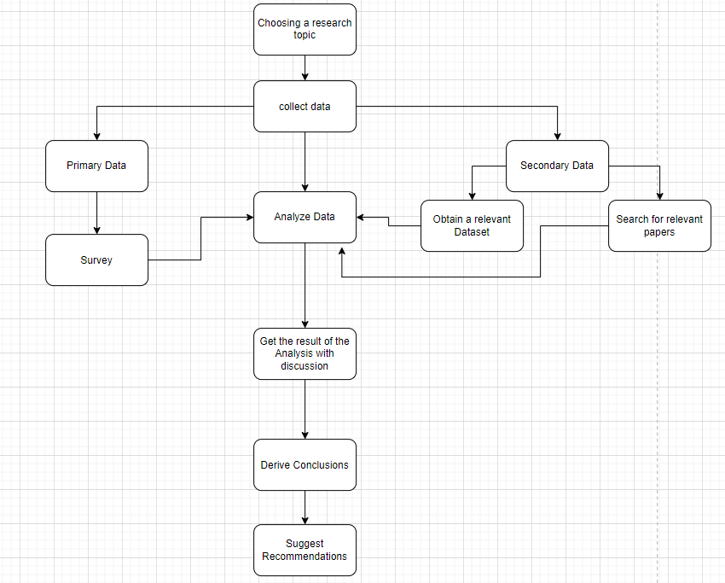

Figure (5): Research approach

# Results and Discussion

**Results from the dataset:**

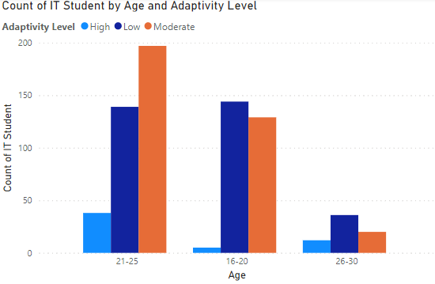

Dataset figure (1)

Older students are more likely to have higher adaptivity level than younger students. In addition to that, The adaptivity of older students is higher maybe because they developed critical thinking and problem-solving because of more life experience, or maybe its due to higher motivation to succeed in their studies.

Dataset figure (2)

We can observe that Higher adaptivity levels are by men.

Dataset figure (3)

We can conclude that People with higher education level have higher adaptability levels than lower education which is positive correlation. This suggest that higher education levels may have more experience or they are more selective with the programs they select.

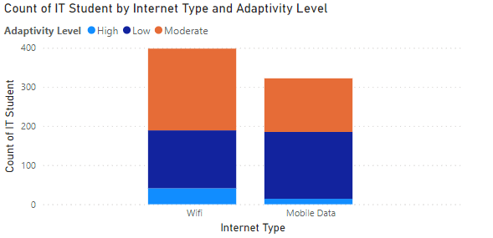

Dataset figure (4)

Students usually uses the internet type that support their adaptability. Wi-fi is more stable and reliable because it shows the adaptability levels are higher in the WIFI category. students who are with low adaptability levels tend to use mobile data more.

Dataset figure (5)

We can see that using self LMS increases the adaptability a lot compared to those who don’t. which indicates that Students are more comfortable with self-LMS. Students who are drawn to self-learning maybe more adaptive to this system.

Dataset figure (6)

High level of adaptability in university than college and school. The lowest level of adaptability was in college. The most moderate level of adaptability was in university.

**Results from the survey:**

1. 58% women, 42% men answered this survey.

Survey figure (1)

1. 75% of the age range was from 16-20 and 25% from 21-25. And no responses from age 26-30.

Survey figure (2)

1. 25% were very satisfied with the overall online learning experience, 33% were somewhat satisfied, 33% were neither satisfied nor dissatisfied, 0% somewhat dissatisfied, 8% were very dissatisfied.

Survey figure (3)

1. aspects of the online learning platform they find most beneficial for their studies.

Survey figure (4)

1. aspects of the online learning platform they find most challenging or frustrating.

Survey figure (5)

1. their satisfaction with the availability and accessibility of course materials (e.g., lectures, readings, assignments) on the online platform. 25% very satisfied, 50% somewhat satisfied, 17% neither satisfied nor dissatisfied, 8% somewhat dissatisfied, 0% very dissatisfied.

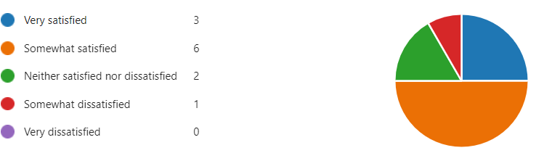

Survey figure (6)

1. satisfaction with the communication and interaction with instructors and classmates in the online learning environment.

0% very satisfied, 33% somewhat satisfied, 25% neither satisfied nor dissatisfied, 33% somewhat dissatisfied, 8% very dissatisfied.

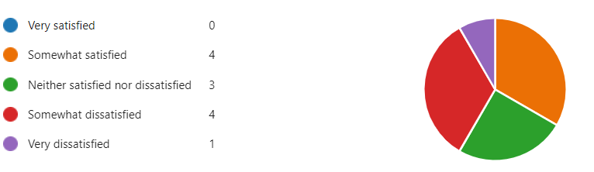

Survey figure (7)

1. Do they feel adequately supported by the online learning platform in terms of technical assistance and troubleshooting?

25% yes, 25% no, 50% maybe.

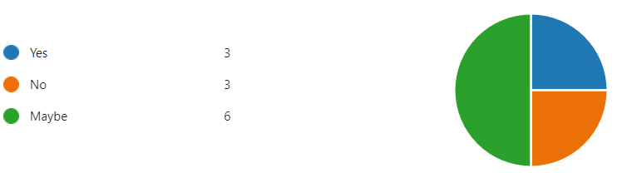

Survey figure (8)

1. The satisfaction with the flexibility and convenience of online learning compared to traditional in-person classes.

17% very satisfied, 50% somewhat satisfied, 25% neither satisfied nor dissatisfied, 0% somewhat dissatisfied, 8% very dissatisfied.

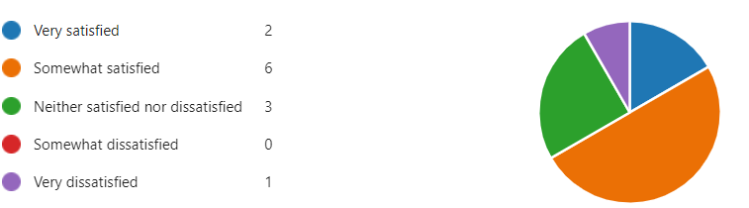

Survey figure (9)

1. what difficulties they Have encountered accessing or navigating the online learning platform.

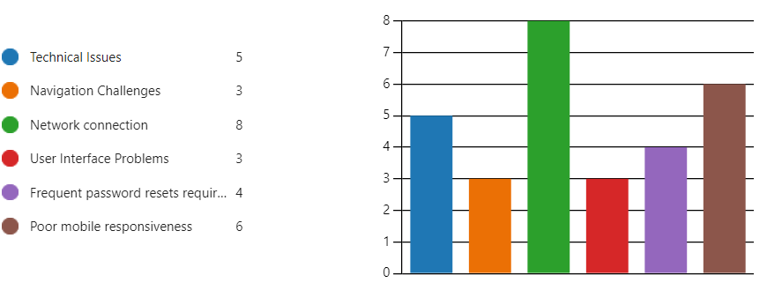

Survey figure (10)

1. How satisfied they are with the clarity and organization of course instructions and materials provided on the online platform.

17% very satisfied, 33% somewhat satisfied, 25% neither satisfied nor dissatisfied, 17% somewhat dissatisfied, 8% very dissatisfied.

Survey figure (11)

1. What additional features or improvements would they like to see implemented in the online learning platform to enhance their learning experience.

* Create online meetings to meet the instructors.
* Improving Interaction with instructors and colleagues.

1. How satisfied are they with the feedback and assessment mechanisms (e.g., quizzes, exams, grading) on the online platform.

8% very satisfied, 25% somewhat satisfied, 42% neither satisfied nor dissatisfied, 25% somewhat dissatisfied, 0% very dissatisfied.

Survey figure (12)

1. How effectively do they think the online learning platform facilitates collaboration and group work with your peers.

0%very effectively, 33% somewhat effectively, 17% neither effectively nor ineffectively, 25% somewhat ineffectively, 25% very ineffectively.

Survey figure (13)

1. Have they experienced any challenges or barriers to participation in online discussions or activities.

75% yes, 25% no.

Survey figure (14)

1. How satisfied are they with the level of engagement and interactivity offered by the online learning platform.

0% very satisfied, 42% somewhat satisfied, 25% neither satisfied nor dissatisfied, 25% somewhat dissatisfied, 8%very dissatisfied.

Survey figure (15).

This study aimed to dig deep into what affects the adaptivity levels of students in online learning with a number of factors such as age, gender, education level, LMS availability, internet type, and network connection. On one hand, The survey results revealed that the most **beneficial** aspects of **LMS** is content quality, flexibility of schedule, and accessibility. On the other hand, the survey also revealed the most **challenging or frustrating** aspects of the LMS system which is the limited to instructor engagement, lack of interactivity, technical issues, limited peer interaction. These results for the LMS directly address the objective by pinpointing specific elements that play a crucial role in students’ ability to adapt to online learning environments. The **availability of LMS** reported higher levels of adaptivity and satisfaction from both the dataset and survey. demonstrating the critical role of LMS in supporting online learning.

After the statistical analysis it showed that varying levels of adaptivity based on **gender, age, and education level**, men and older students and those with higher education levels adapted more easily. These findings support the objective by highlighting how demographic characteristics affect adaptivity.

The **effects of internet and network types** were found to have a substantial impact on students’ adaptivity, with WI-FI being the most stable and high-speed connection facilitating better learning experiences. This aligns with the objectives by showing how different internet and network types affect students’ ability to adapt to online learning. The findings provided concrete evidence on the importance of internet quality.

.

The analysis benefited from comprehensive data collection methods, including both quantitative and qualitative data from surveys, this enhanced the depth and breadth of the findings. The use of Power BI enabled accurate identification and prediction of key factors affecting student adaptability, this provided reliable and valid results to support the study's conclusions and recommendations. Microsoft Forms facilitated real-time data collection and instant feedback, this enabled immediate interpretation of trends.

The limits of the analysis are present. Firstly, The reliance on self-reported data from surveys may introduce bias opinion, this may affect the validity and reliability of the findings, as the responses might not fully represent the actual behaviors or attitudes of the participants. Moreover, the survey only captures students' experiences in a single point in time, limiting the ability to observe changes and trends over time. Furthermore, it is hard to generalize on a broad level due to the lack of diversity in the participants’ demographic backgrounds.

The dataset analysis provided some merits like understanding how different factors affected their adaptivity and satisfaction in online learning like gender, age, education level, internet type, and self-LMS. These features leveraged our understanding to uncover new insights into students experience, identify success factors to online learning, and help develop ways to improve online learning. Furthermore, advanced analysis tools were used to enhance the accuracy of the study, leading to satisfying student’s needs. In this analysis, we observed that men and older students and those with higher education levels adapted more easily. And also we found that the availability of LMS system has a huge impact on the adaptivity levels.

However, limits were identified the dataset quality was not high due some feature values were missing, potential bias measures in data collection, wrong values were observed in the age feature so I had to transform the data. Moreover, the data does not capture changes overtime or another factors that may influence the online learning experience. Despite these limits, the analysis can give critical insights in the digital education world.

The survey gave us an understanding on how age, education level, technical issues, and LMS system aspects they find most challenging or frustrating like lack of interactivity, limited instructor engagement, limited peer engagement, and technical issues and the most beneficial aspects like accessibility of resources, content quality, flexibility of schedule which affects the overall satisfaction experience. Moreover, suggestions for additional improvements and features to enhance the learning experience.

The limits of the survey analysis were it was not accurate due to the low number of participants and the questions did not have a sense of depth to it. knowing that we can have useful insights even with these limitations.

# Conclusion and Recommendations

This study aimed to investigate some factors that influenced the adaptability and satisfaction of students in online learning. Focusing on institution context, technological access, and demographic characteristics. The analysis showed that age and education level increases the adaptability if they are higher, men are more adaptable to online learning, and the availability of a WIFI connection is crucial for their adaptivity. It was found that LMS systems and good network connections are crucial because of their reliability. Moreover, it showed that men is most likely to adapt in the digital environment. The study have shed light on the importance of tailored interventions and support mechanisms to address the diverse needs of students, to enhance the overall online learning experience.

Based on the findings there are a couple of recommendations to enhance the adaptability of students in online education environments. First of all, we can support diverse student needs by ensuring robust and user-friendly LMS for educational institutions. Secondly, enhance the overall internet infrastructure to provide reliable network connections, this is crucial because it will help to overcome technological challenges, and to those who are in underserved areas. Demographic groups should get tailored support and offer the needed resources to address specific needs. Moreover, making the online learning environment more interactive and engaging through multimedia content and collaborative tools. Furthermore implementing a continuous feedback mechanism to monitor students satisfaction and measure their adaptability to make iterative improvements to the online learning experience. By implementing these recommendations, educational institutions can create more inclusive, supportive, and effective online learning environments for all students.

For future advancements to this study maybe I will address different age segments, measuring motivation level, assess instructor responsiveness and peer interactions, and mental health effect on student adaptability. To provide a more detailed and holistic understanding of the factors influencing student adaptability and satisfaction in online learning environments.

# Reflection

### Selected research methodology

Understanding the adaptivity level and satisfaction of students in online learning environments requires a meticulous research process. A literature review was conducted to help identify key factors that influence their experience. A survey was conducted based on the insights from the literature review incorporating mixed method which is quantitative and qualitative type of questions to capture a holistic view of student's experiences. Demographics, technological access, and institutional support were covered in the conducted survey, which allowed for a nuanced understanding of the analysis. To maximize the reach I utilized the university’s groups, emails, and official websites for students. The visualization of the data was represented by the Microsoft team forms for quantitative data and thematic analysis for the qualitative data. Consent from the students were needed to abide by ethical guidelines, and the participants identity are anonymous in the survey. This research process helped me to recognize the value of combining quantitative and qualitative methods to enrich the findings and provide deeper insights into the factors influencing online learning adaptivity.

**Data collection**, I was able to utilize Microsoft Forms for survey which facilitated a smooth data collection process due to its user-friendly interface and real-time data collection capabilities, but the survey design was challenging to capture all relevant aspects of the research questions and maintaining respondent engagement required careful planning. **Data analysis,** the use of Power BI provided valuable insights and helped achieve the research objectives, This technique enhanced the accuracy and depth of the analysis, as well as combining quantitative and qualitative methodologies, transforming data was a challenge because age and class duration features contained values that needed to be cleaned using power BI. **Results Interpretation and Discussion,** I was able to align the findings with he research objectives, providing clear answers to the research questions and the study generated practical recommendations to improve online learning experiences.

Quantitative and qualitative methodologies both offered some merits. Identifying trends and measuring the effects of different factors that affects the adaptivity were provided by the quantitative method that provided a structured and statistical foundation. This helped to generalize the findings across a larger population. On the other hand, qualitative method helped to gain new insights from the students perspective and experience, which statistics and numbers do not provide. This mixed method helped to get a comprehensive analysis, bridging the gap between broad trends and individual experiences.

But these methodologies also have some limitations, for example quantitative surveys may not capture the full student experiences and could capture bias opinions or limited response options. On the other hand, qualitative questions, although it can give other people opinions or suggestions, it is time consuming to analyze and it is hard to generalize on the whole population, moreover the responses is influenced by the willingness of participants to share their opinions openly and wording of the question can also influence on the responses.

Online surveys were definitely a pitfall due to low response rate, which leads to an underrepresented groups. The design of the survey was a challenge to ensure the reliability and validity of the survey. Furthermore, qualitative data analysis have a subjective nature so the researcher can pick and choose the answer that fits his opinions.

### Alternative research methodologies

An Alternative methodology for the research could be conducting interviews with students to pinpoint specific needs or suggestions from their mouths with an in-depth questions that can benefit and enrich the researcher's perspective. Moreover, use experimental methodology, the researchers intervenes and conduct experiments in the middle of the process to measure the outcome, This method will help in gaining more control over the cofounding variables and can establish causality, but it also has some cons like influencing the research subject in unexpected ways and it requires more expertise and resources to collect data [16]. To implement the experimental methodology we can compare groups with consistent LMS access against those with intermittent access, to determine who has more adaptivity level.

**Data collection quality** is vital because The accuracy and reliability of data are paramount, Utilizing tools like Microsoft Forms ensured efficient and organized data collection, however, the dataset needed some transforming and data cleaning. This provided a solid foundation for analysis, the data needed careful attention to maintain the integrity of the analysis. **analysis and interpretation,** a detailed analysis and understanding of the relationships between variables, requires a deep understanding of statistical methods. The use of advanced statistical techniques provided robust insights, confirming the hypotheses and revealing the significant impact of LMS access, internet connectivity, and instructional strategies on student adaptability and satisfaction. **Ethical considerations,** maintaining ethical integrity and trust is vital to the research process like informed consent, data confidentiality, and participant debriefing. This helps in contributing to the study’s credibility and fosters a positive relationship with participants, which is crucial for future research endeavors. **Adaptability to challenges**, adjusting the research design or data collection methods in response to emerging issues, is critical, because research processes usually face challenges, so you should be adaptive and flexible in the approach. If you gain the ability to adapt to challenges, such as dealing with incomplete data or ensuring participant engagement, it ensures the research continues smoothly and produces valid results.

### Recommended actions and future considerations

We can address low response rate in online surveys through combining online surveys with telephone and face-to-face interviews so we reach a higher number of the population, moreover, utilizing social media to increase the participation rate. Bias opinions should be mitigated by including more objective measures. Furthermore, qualitative data collection could be improved by incorporating in-depth interviews in addition to open-ended questions, to gain more in-depth insights for student's experience. Moreover, pilot testing and feedback from participants is crucial so we should strive to continuously refine the survey to ensure that questions are clear, relevant and capable of capturing the intended data, this helps to dig deeper into specific areas that are important such as time management skills and mental health. Lastly, longitudinal studies should be considered to track changes over time for students adaptivity and satisfaction, By adopting a more dynamic and adaptive research design, future studies can better capture the evolving nature of online learning experiences.

### Recommended Methodology

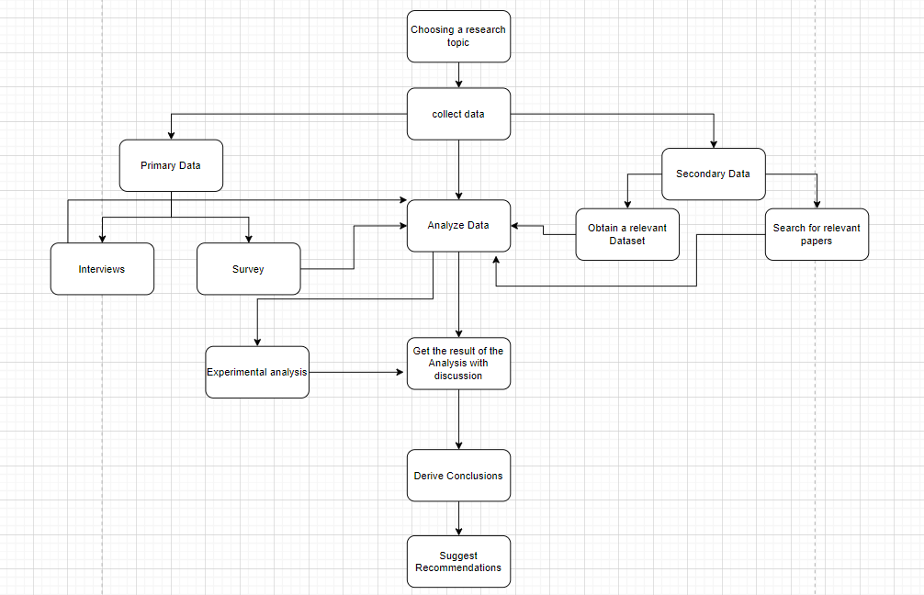

Figure (6): updated version of research methodology

In the updated version of the research methodology interviews were added under the primary data to allow the collection of qualitative data to enrich and give detailed insights into their personal experiences and challenges in online learning after being analyzed. Moreover, experimental analysis were added to test specific hypotheses related to student adaptability. For instance, experiments could be designed to compare the effectiveness of different instructional strategies or types of internet connectivity on student performance and adaptability. This approach helps in establishing causality and understanding the direct impact of various factors on student adaptability. Then analyze the results of the experiment with a discussion.

**References**

[1] D. Y. Baskakova, O. Y. Belash and S. O. Shaposhnikov, "Assessment of Online Learning Effectiveness by Students of Engineering and IT Degree Programs," 2021 International Conference on Quality Management, Transport and Information Security, Information Technologies (IT&QM&IS), Yaroslavl, Russian Federation, 2021, pp. 783-787, doi:10.1109/ITQMIS53292.2021.9642752.

[2] Li, Z., Lou, X., Chen, M. *et al.* Students’ online learning adaptability and their continuous usage intention across different disciplines. *Humanit Soc Sci Commun* **10**, 838 (2023). <https://doi.org/10.1057/s41599-023-02376-5>

[3] M. Sree, J. J. James, A. Shaji and A. M. Kuruvilla, "Estimation of Learners' Levels of Adaptability in Online Education Using Imbalanced Dataset," 2023 IEEE International Conference on Recent Advances in Systems Science and Engineering (RASSE), Kerala, India, 2023, pp. 1-7, doi: 10.1109/RASSE60029.2023.10363543.

[4] Teslyuk, V., Doroshenko, A. and Savchuk, D., 2023. Intelligent Methods and Models for Assessing Level of Student Adaptation to Online Learning. In COLINS (1) (pp. 331-343).

[5] J. E. Yoo, M. Rho and Y. Lee, "Online Students’ Learning Behaviors and Academic Success: An Analysis of LMS Log Data From Flipped Classrooms via Regularization," in IEEE Access, vol. 10, pp. 10740-10753, 2022, doi: 10.1109/ACCESS.2022.3144625.

[6] R. Conijn, C. Snijders, A. Kleingeld and U. Matzat, "Predicting Student Performance from LMS Data: A Comparison of 17 Blended Courses Using Moodle LMS," in IEEE Transactions on Learning Technologies, vol. 10, no. 1, pp. 17-29, 1 Jan.-March 2017, doi: 10.1109/TLT.2016.2616312.

[7] H. Lee, "The Rise and Challenges of Postpandemic Online Education," in IEEE Engineering Management Review, vol. 49, no. 4, pp. 54-58, 1 Fourthquarter,Dec. 2021, doi: 10.1109/EMR.2021.3105195.

[8] Malik, A., Onyema, E.M., Dalal, S., Lilhore, U.K., Anand, D., Sharma, A. and Simaiya, S., 2023. Forecasting students' adaptability in online entrepreneurship education using modified ensemble machine learning model. Array, 19, p.100303.

[9] Răducu, C.M. and Stănculescu, E., 2021. Adaptability to online teaching during Covid-19 pandemic: A multiple mediation analysis based on Kolb’s theory. International Journal of Environmental Research and Public Health, 18(15), p.8032.

[10] Xie, X., Lin, F. and Zhang, T., 2001. Comparison between on-and off-campus behaviour and adaptability in online learning: a case from China. Behaviour & Information Technology, 20(4), pp.281-291.

[11] M. Hasan Suzan, N. A. Samrin, A. A. Biswas and A. Pramanik, "Students' Adaptability Level Prediction in Online Education using Machine Learning Approaches," 2021 12th International Conference on Computing Communication and Networking Technologies (ICCCNT), Kharagpur, India, 2021, pp. 1-7, doi: 10.1109/ICCCNT51525.2021.9579741.

[12] Iparraguirre-Villanueva, O., Torres-Ceclén, C., Epifanía-Huerta, A., Castro-Leon, G., Melgarejo-Graciano, M., Zapata-Paulini, J. and Cabanillas-Carbonell, M., 2023. Comparison of predictive machine learning models to predict the level of adaptability of students in online education.

[13] Pillay, N.S., Okonkwo, C.W. and Anele, A., 2023. The impact of loadshedding on student academic performance: A data analytics approach. In Association with, p.329.

[14] S. Salloum, J. Z. Huang and Y. He, "Random Sample Partition: A Distributed Data Model for Big Data Analysis," in IEEE Transactions on Industrial Informatics, vol. 15, no. 11, pp. 5846-5854, Nov. 2019, doi: 10.1109/TII.2019.2912723.

[15] A. Melnikovas, “Adapting Research Onion Model for Futures Studies,” [https: //www.semanticscholar.org/paper/Towards-an-Explicit-Research-Methodology-% 3A-Adapting-Melnikovas/dccf54a5a4312ceb2261e1989cda01f73989d735,](https://www.semanticscholar.org/paper/Towards-an-Explicit-Research-Methodology-%3A-Adapting-Melnikovas/dccf54a5a4312ceb2261e1989cda01f73989d735) 2018, [Online; accessed 10-Jan-2024].

[16] <https://www.scribbr.com/category/methodology/>

[17]https://byjus.com/commerce/difference-between-primary-data-and-secondary-data/